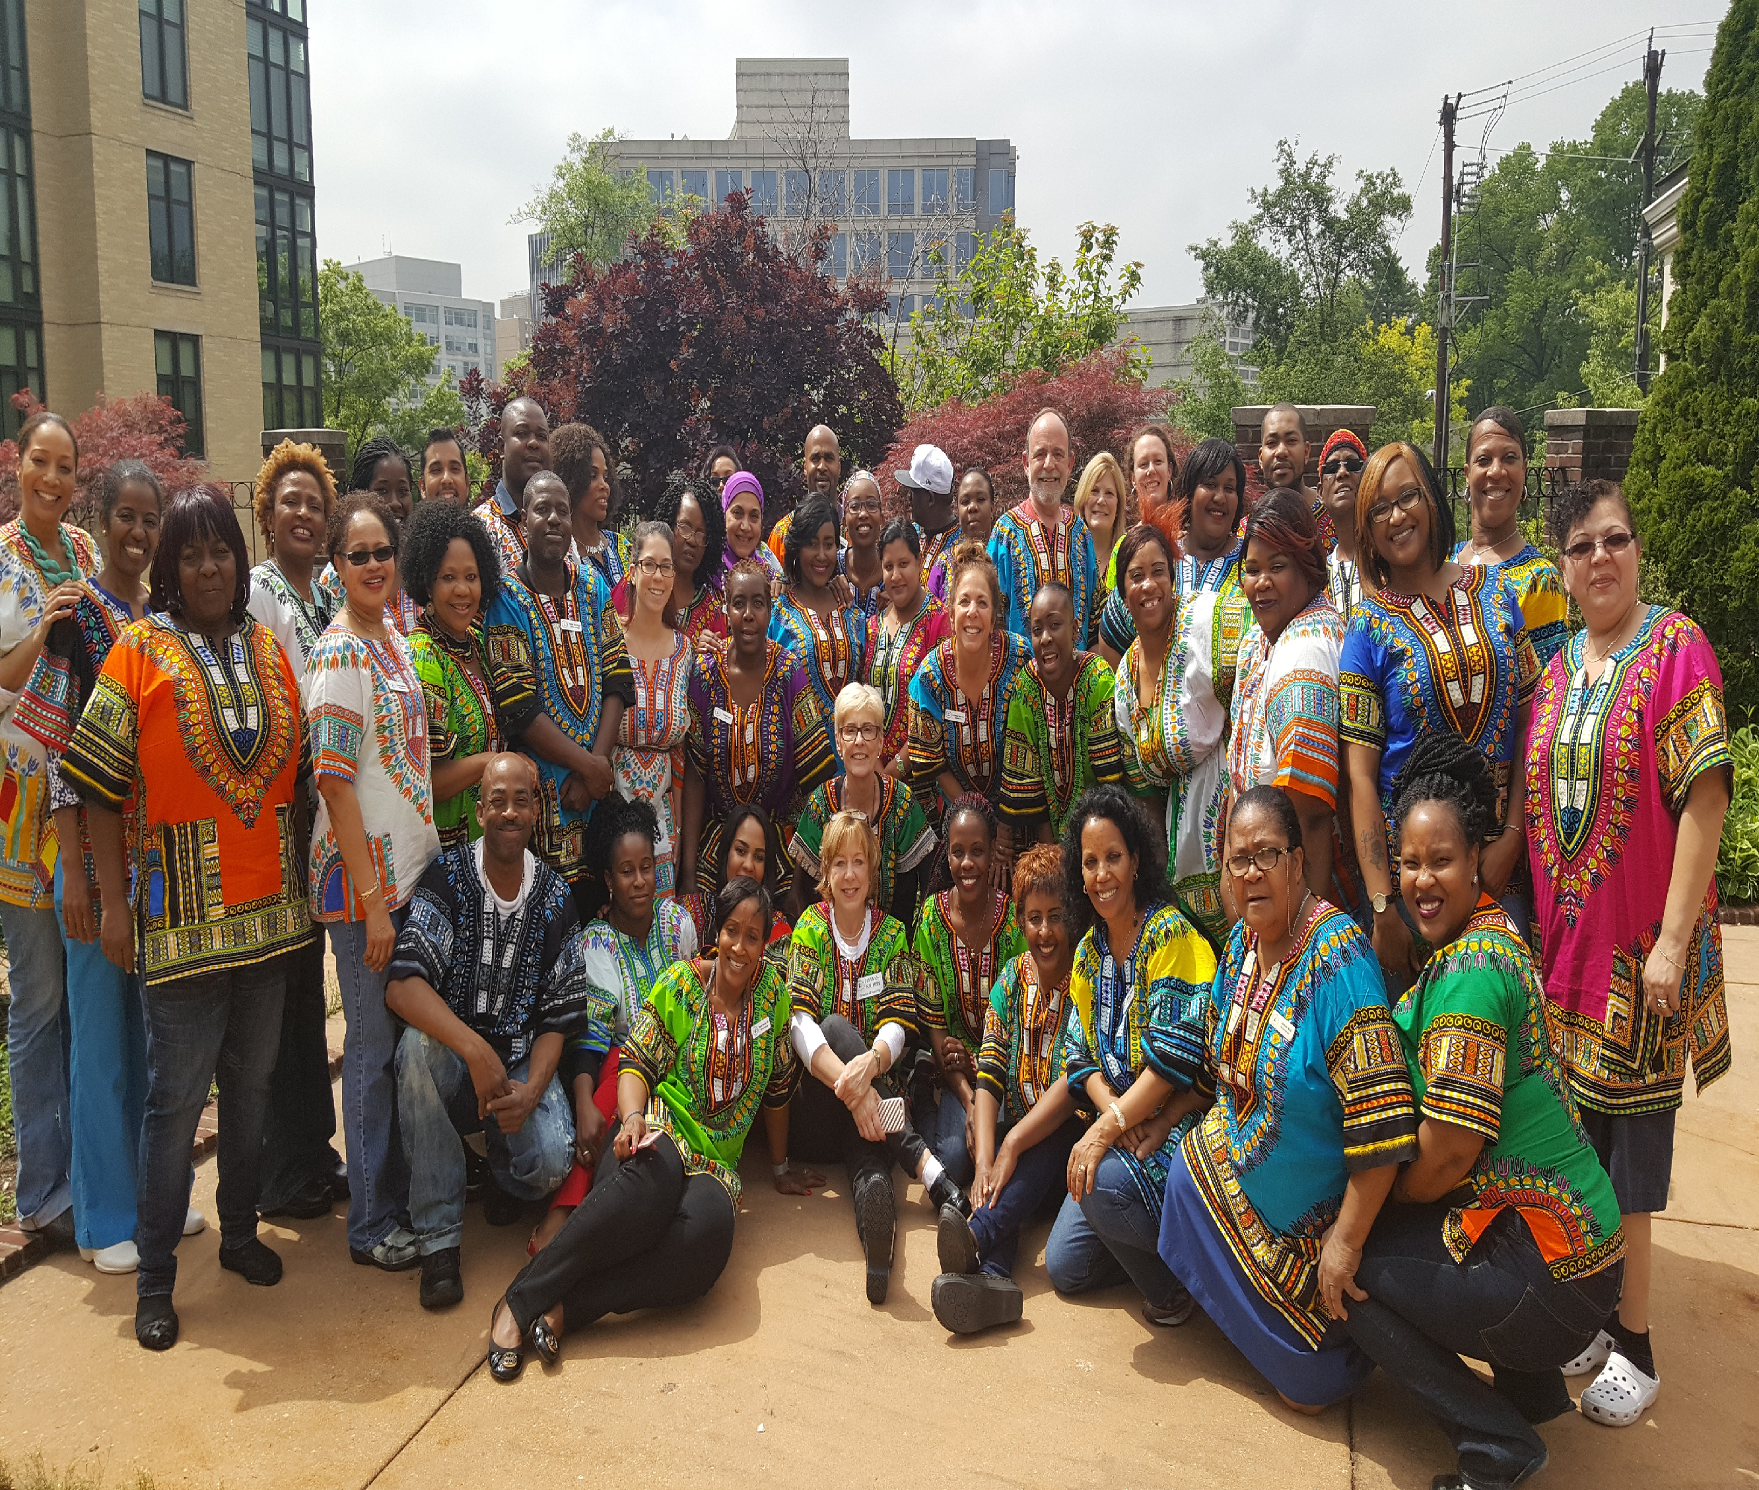
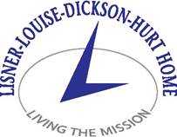
We strive to be a champion for economically disadvantaged elders of DC, working to alleviate their hardships in a manner which recognizes their self-worth and promotes their dignity and independence. The mission of the Lisner-Louise-Dickson-Hurt Home is to provide extraordinary health and life care services to low and modest income seniors of the District of Columbia, empowering them to live their lives to the fullest.
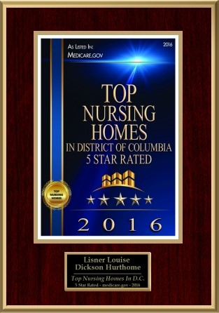

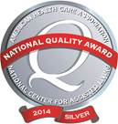
“Staff of Lisner-Louise-Dickson-Hurt Home”

Dear January 25, 2017

The Lisner-Louise-Dickson-Hurt Home will once again be hosting a spring fundraising event on the grounds of the Home. This year, the event will be held on May 25th, which is recognized annually in the United States as “National Wine Day.” We will be featuring specialty wines along with fabulous cuisine, beer, and nonalcoholic beverages. Live music will again be provided by the renowned Washington, DC-based Trio Caliente. The Resident Art Gallery will also be open for attendees to view and purchase artwork.
We are currently in the planning stages of this event and depend entirely on corporate and private sponsorship for financial support. It is our hope that… will sponsor this year’s event. Your much- needed sponsorship will assist the Home in continuing to enhance the quality of life for our residents through our core programs of support: health care, food and nutrition, housing, and social services/recreational activities. With your help, we can continue to meet the challenges of caring for those elder poor of the city who can no longer care for themselves.

I have enclosed for your information a summary of the 2017 sponsorship levels and benefits along with a sponsorship form; please be assured that your financial support will, as always, be recognized and greatly appreciated. We hope to hear from you no later than February 28th as we will be printing the invitations and would like to include your name in our list of sponsors.
Many thanks in advance for your sponsorship consideration. Should you have any questions about this opportunity or the event, please feel free to contact me directly at 202-966-6667 ext. 3311 or via email at lworem@lldhhome.org. Our Development Coordinator, Debbie Lyle, may also be reached at ext. 3373 or via email dlyle@lldhhome.org.
Sincerely,

L. Ward Orem, MA, LNHA
CEO
Enclosures
Lisner-Louise-Dickson-Hurt Home
Celebration of “National Wine Day” Fundraiser
May 25, 2017
CORPORATE/INDIVIDUAL SPONSORSHIP FORM

Platinum Sponsor at $10,000 and above

- 10 complimentary tickets
- Full page ad in program
- Company logo on Home’s website with link to company website
- Company/individual recognition in three monthly editions of the Home’s
E-newsletter: Living the Mission
- Company/individual recognition on the Home’s Fiscal Year 2017 donor wall

Gold Sponsor at $5,000 and above

- 6 complimentary tickets
- Half page ad in program
- Company logo on Home’s website with link to company website
- Company/individual recognition on the Home’s Fiscal Year 2017 donor wall

Silver Sponsor at $2,500 and above

- 4 complimentary tickets
- Listing in program
- Company logo on Home’s website with link to company website
- Company/individual recognition on the Home’s Fiscal Year 2017 donor wall

Bronze Sponsor at $1,000 and above

- 2 complimentary tickets
- Company logo on Home’s website with link to company website
- Company/individual recognition on the Home’s Fiscal Year 2017 donor wall

Friend Sponsor at $500 and above

- 1 complimentary ticket
- Company/individual recognition on the Home’s Fiscal Year 2017 donor wall

Sponsor Level / Amount ___________________________________________________

Corporate/individual name of sponsor as it is to appear______________________

_____________________________________________________________

Corporate contact (if applicable) ___________________________________________

Contact phone and email _________________________________________________

Website address (if applicable) ____________________________________________

Please charge VISA/AMEX/DISCOVER/MASTERCARD:

Card No.____________________________ Expiration Date ______________________

Name as it appears on card _______________________________________________

Billing Address _________________________________________________________

__________________________________________________________

Signature___________________________________Date _________________________

CHECKS SHOULD BE MADE PAYABLE TO LISNER-LOUISE-DICKSON-HURT HOME.

ALL SPONSORSHIPS ARE TAX DEDUCTIBLE TO THE EXTENT PERMITTED BY LAW. THE HOME IS A 501(C)3 TAX EXEMPT PUBLIC CHARITY.

WE THANK YOU FOR YOUR SUPPORT

LISNER-LOUISE-DICKSON-HURT HOME
BOARD MEMBERS FY 2017

Our History

In the 1930’s, Abraham Lisner and his wife, Laura, could not have predicted the extent to which
their dream of providing a safe haven for the elderly poor of the nation’s capital would be
realized. Known originally as Abraham and Laura Lisner Home for Aged Women, we are now
referred to as the Lisner-Louise-Dickson-Hurt Home. The latter names were added in tribute to
three other foundations, with very similar missions, which embraced the Home’s charitable
philosophy by becoming and remaining, to date, our largest contributors. Today, the Home
offers a wide range of personalized short-term, long-term, and rehabilitative care to a diverse
population of 100+ women and men within the comfortable, private surroundings of its historic
residence in Washington, D.C.

Abraham and Laura The Louise Home
Lisner Home for Aged Women (Affiliated 1976)
Christopher E. Tawa, President Philip O’Donoghue, President
Christine Hobbs, Vice President Philip Israel, Jr.
Marnie T. Kagan, Treasurer Deirdre Parrot
David Leopold, Secretary Virginia Pascoe
Robert Cooper
Tom Dillon The John Dickson Home
Matthew Frumin (Affiliated 1985)
Barbara Ingraham
Patricia Johnson Terence W. Collins, President
Carolyn Nazdin Art Elgin
Haydn Richards Jean Hartman
L. Ward Orem (Ex-Officio) Barbara Ingraham
Patricia Johnson
Abraham and Laura Lisner
Home for Aged Women The Henry and Annie Hurt Home
Emeritus Board of Directors For the Blind (Affiliated 1993)

B. Bernei Burgunder, Jr. Terence W. Collins, President
Eva Nash Barbara Ingraham
David Povich The Rev. Dr. William Hague
Matthew Tobriner
Gretchen Wharton The Elizabeth R. Shoemaker Home
(Affiliated 2006)

Terence W. Collins, President
Stephanie deSibour
Tom Dillon
Margaret Eastman
Barbara Ingraham
Patricia Johnson
Judith Martin

